**CI/CD Deployment for Spring Boot Application**

**Developer name :** Nagendra K N

**Project Details :**

I have built a CI/CD pipeline to demonstrate continuous deployment and host the application on AWS EC2 instance.

**Requirements:**

**Softwares used :** Eclipse IDE

**Version control tool :** GIT hub

**Programming language :** Java programming

**Framework :** SpringBoot

**Build Tool :** Jenkins

**Cloud instance :** AWS EC2

**Git Hub:**

Source code is pushed into git

**Link : https://github.com/Nagendrakn19/Phase5_SpringBoot.git**

**Steps used for the project :**

* Create the Spring boot project in Eclipse and complete the code
* Run the code and test whether its working properly.
* Then push the code to git.
* Open Jekins and start then create a new pipeline job in the Jenkins provide the git url and configure it, write the suitable script suitable for your operation inside pipeline script. The following shows the script used in pipeline script:

pipeline {

agent any

tools {

// Install the Maven version configured as "M3" and add it to the path.

maven "MyMaven"

git "MyGit"

}

stages {

stage('Build') {

steps {

// Get some code from a GitHub repository

git branch: 'main', url: 'https://github.com/Nagendrakn19/Phase5_SpringBoot.git'

// Run Maven on a Unix agent.

sh "mvn -Dmaven.test.failure.ignore=true clean package"

}

}

stage('Install') {

steps {

// Get some code from a GitHub repository

git branch: 'main', url: 'https://github.com/Nagendrakn19/Phase5_SpringBoot.git'

// Run Maven on a Unix agent.

sh "mvn -Dmaven.test.failure.ignore=true install package"

}

}

stage('Compile') {

steps {

// Get some code from a GitHub repository

git branch: 'main', url: 'https://github.com/Nagendrakn19/Phase5_SpringBoot.git'

// Run Maven on a Unix agent.

sh "mvn -Dmaven.test.failure.ignore=true compile package"

}

}

}

}

* You can observe the pipeline job doing in the Job created in Jenkins. Output screenshot is attached in the Output section.
* Then created aws ec2 instance with free version then install java, maven, git in the cloud instance.
* Then s3 bucket was created to store and move the jar file into cloud instance.
* Once its moved to cloud instance java –jar SpringBootRest.jar command was executed and application started successfully and related output was obtained.

**Note :** Please refer to output section for all the screen shots.

**Commands used in ec2 instance :**

* Update ec2 instance : sudo yum -y update
* Install maven :

sudo wget https://repos.fedorapeople.org/repos/dchen/apache-maven/epel-apache-maven.repo -O /etc/yum.repos.d/epel-apache-maven.repo

sudo sed -i s/\$releasever/6/g /etc/yum.repos.d/epel-apache-maven.repo

sudo yum install -y apache-maven

* Install git : sudo yum install git –y
* Fetching jar file from s3 bucket :

wget <https://springbootbucket2.s3.amazonaws.com/springboot/SpringBootRest.jar>

* Running jar file : java –jar SpringBootRest.jar

**Output Screenshots :**

**Builing Jobs with Jenkins :**

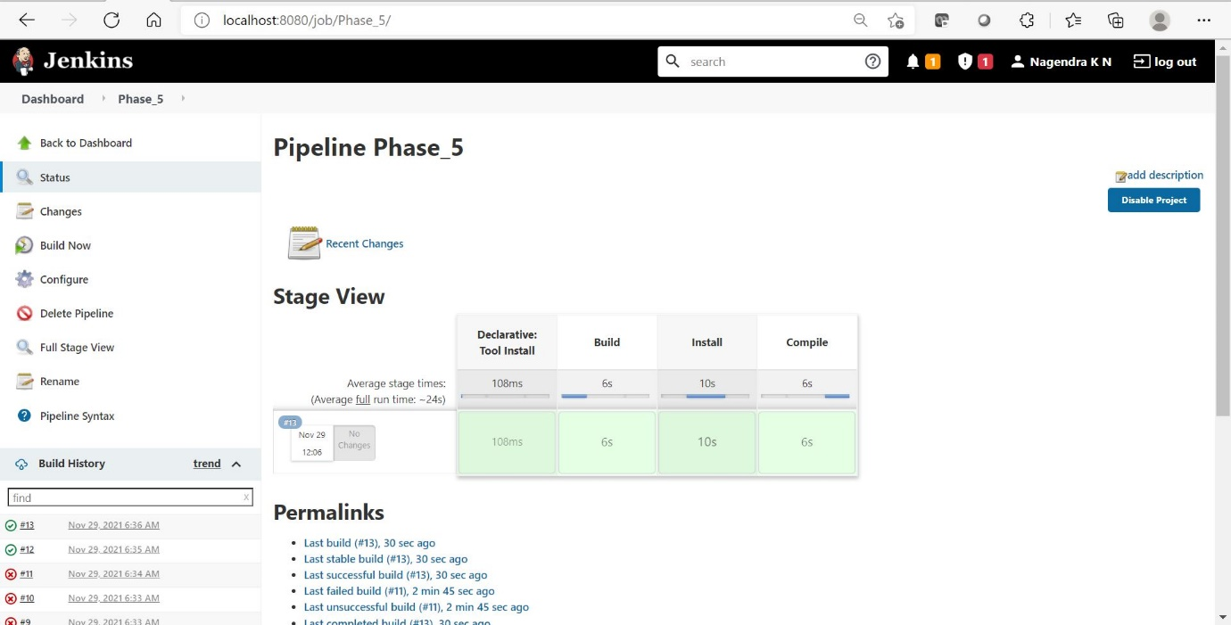

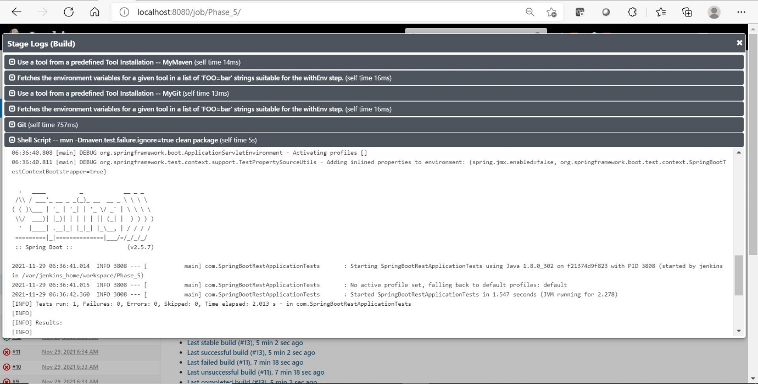

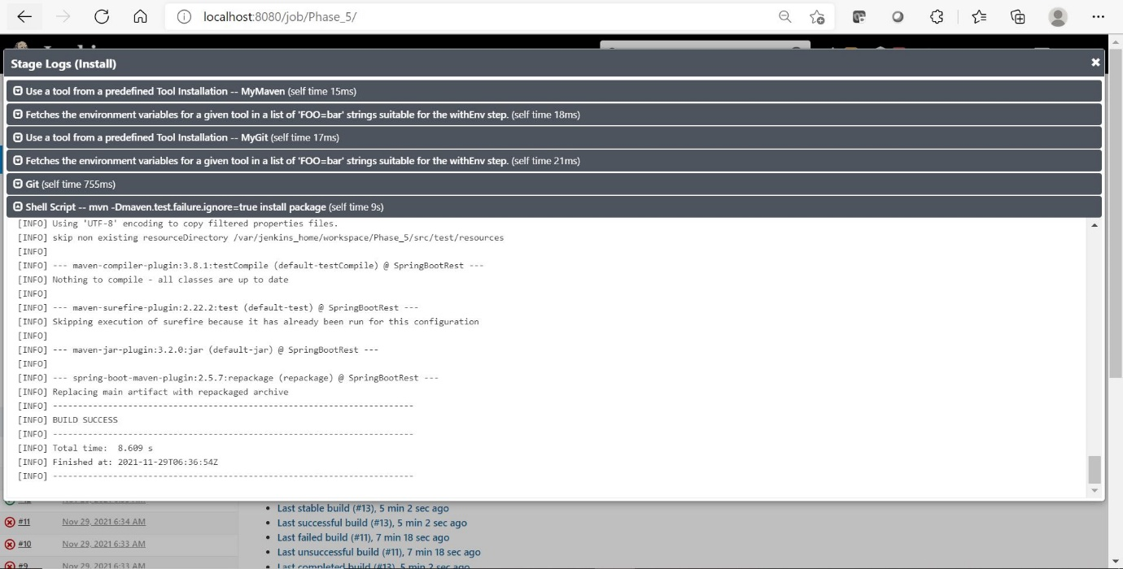

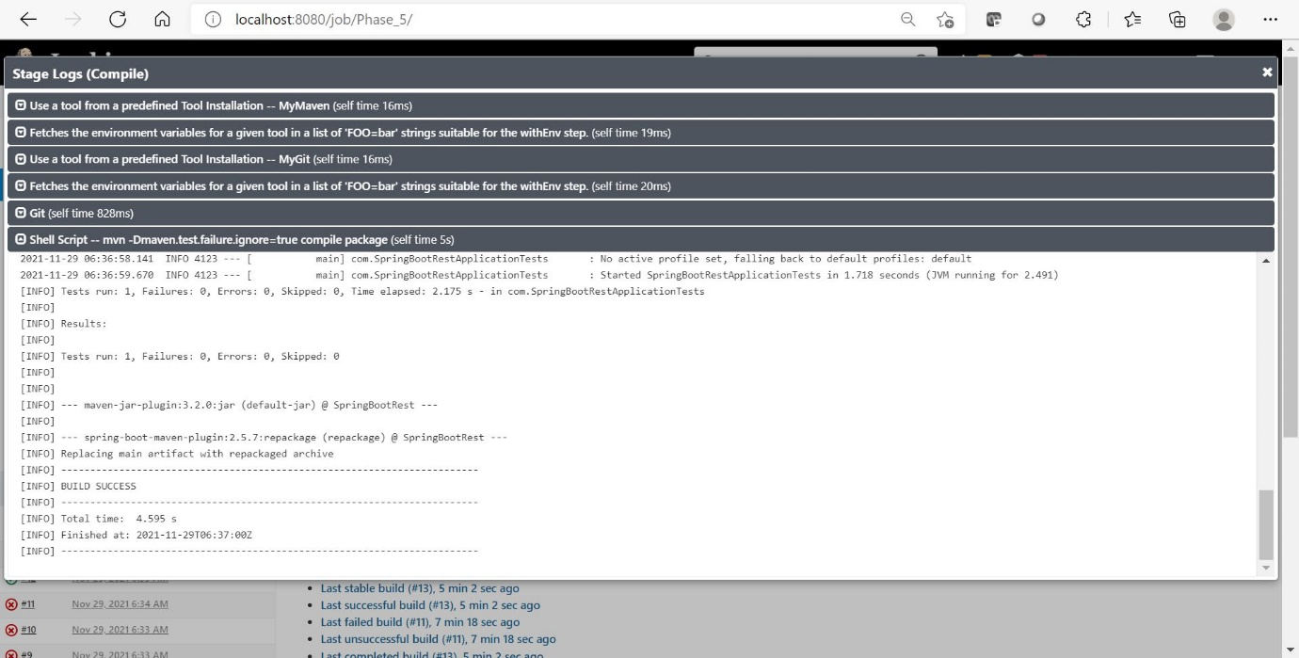

**Ec2 instance created and running :**

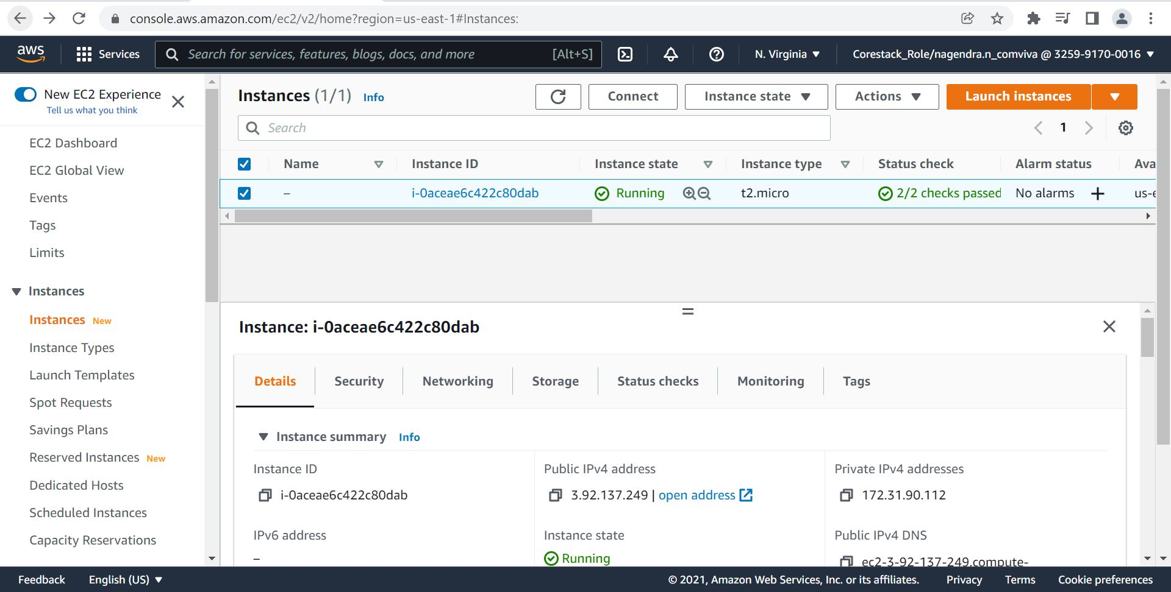

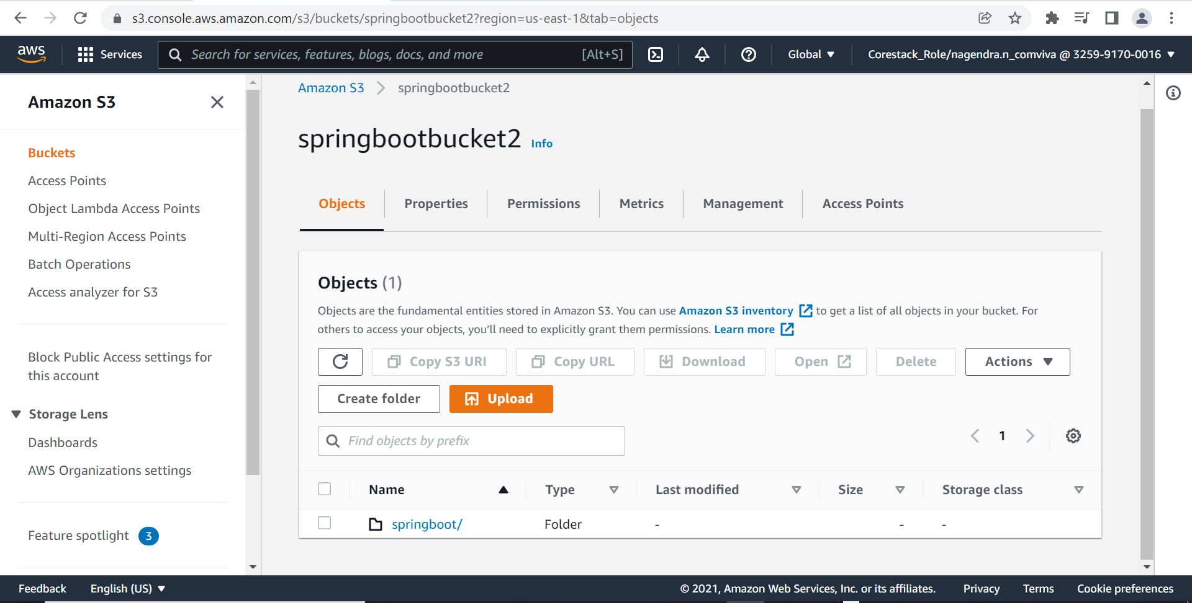

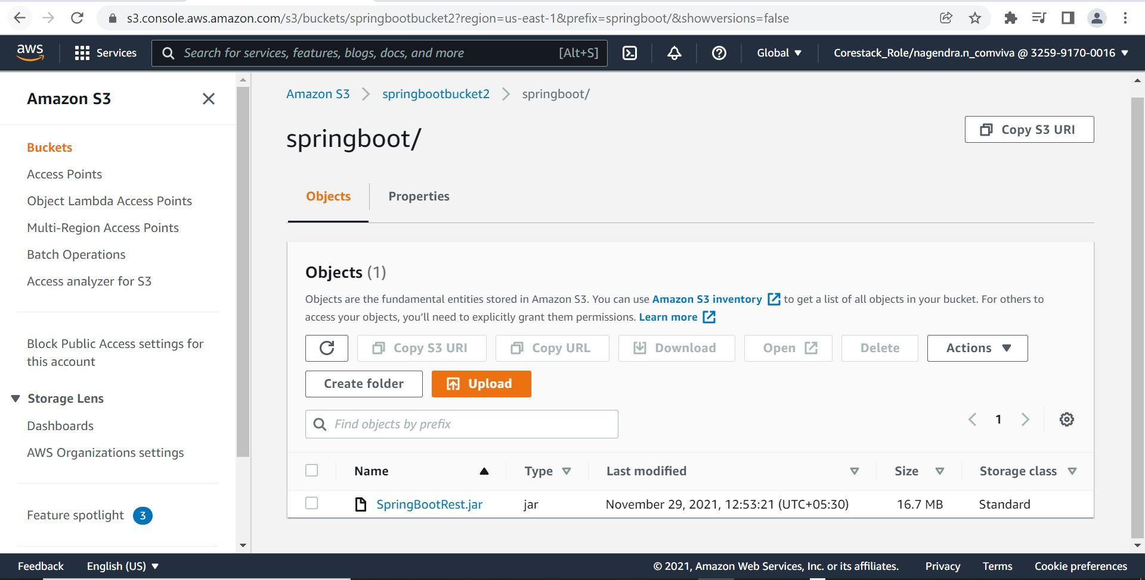

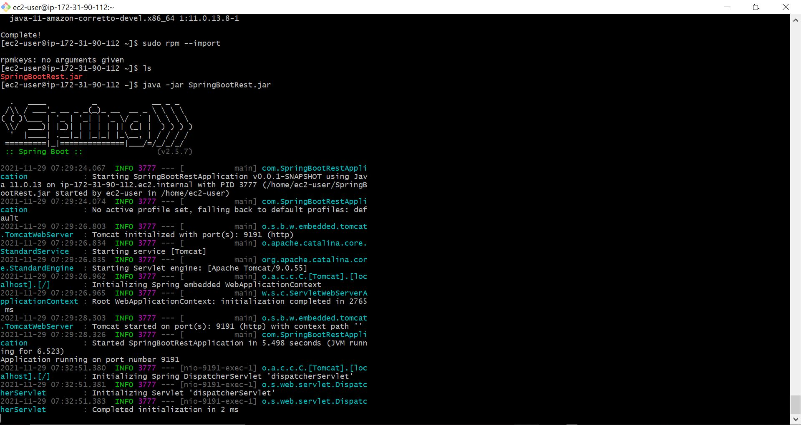

**Ouptut after running application in cloud :**

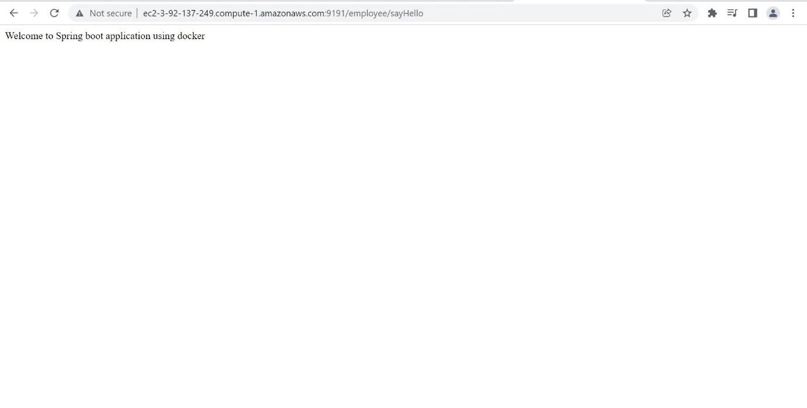

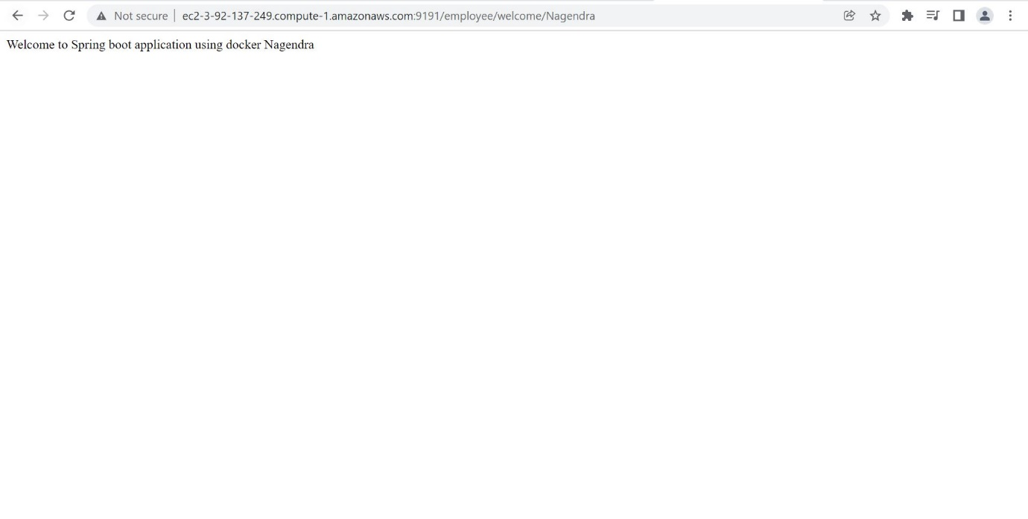

**Server was also accessible from mobile device :**



